**Day 22 - Binary Search Trees**

<https://www.hackerrank.com/challenges/30-binary-search-trees/problem>

**Objective**  
Today, we're working with Binary Search Trees (BSTs). Check out the [Tutorial](https://www.hackerrank.com/challenges/30-binary-search-trees/tutorial) tab for learning materials and an instructional video!

**Task**  
The height of a binary search tree is the number of edges between the tree's root and its furthest leaf. You are given a pointer, root, pointing to the root of a binary search tree. Complete the getHeight function provided in your editor so that it returns the height of the binary search tree.

**Input Format**

The locked stub code in your editor reads the following inputs and assembles them into a binary search tree:  
The first line contains an integer, n, denoting the number of nodes in the tree.  
Each of the n subsequent lines contains an integer, data, denoting the value of an element that must be added to the BST.

**Output Format**

The locked stub code in your editor will print the integer returned by your getHeight function denoting the height of the BST.

**Sample Input**

7

3

5

2

1

4

6

7

**Sample Output**

3

**Explanation**

The input forms the following BST:

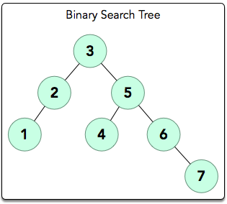

The longest root-to-leaf path is shown below:

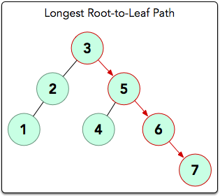

There are 4 nodes in this path that are connected by 3 edges, meaning our BST's height = 3. Thus, we print 3 as our answer.